Practical no. 9
Name :- Danish Altaf Solkar Enrolment no. :-24111590805
Class :- CO3K – B Subject :- DMS
Aim:- Implement Relational operators to apply various conditions in query

QUERY :- select * from ARKP where marks = 20;
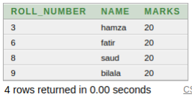

QUERY :- select * from ARKP where marks != 20;
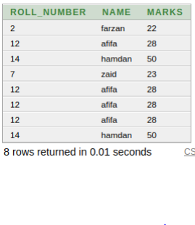

QUERY :- select * from ARKP where marks > 28;
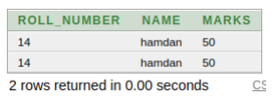

QUERY :- select * from ARKP where marks >= 28 ;
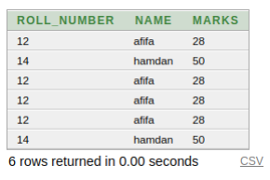

QUERY :- select * from ARKP where marks < 28;
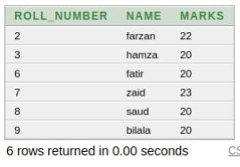

QUERY :- select * from ARKP where marks <= 20;
